(Approx. 1,286 words)

What Do You Use To Frame Your Digital Images
By Fran Damratowski, Refurbishing SIG Chair, Chesapeake PC Users Group, MD
www.chesapeakepcusersgroup.org
Refurbishing(at)chesapeakepcusersgroup.org

Obtained from APCUG with the author's permission for publication by APCUG member groups.

When using a 35mm camera photos are framed using a viewfinder. One of two basic types of viewfinders is used. One type used by single lens reflex (SLR) cameras is a through the lens (TTL) optical viewfinder. The SLR TTL viewfinders use a mirror and pentaprism or porro finder to reflect the light/image directly through the lens to the viewfinder without changing the light/image (what you see is what you get). The second types are optical viewfinders that do not project the actual image directly to the viewfinder. They are (1) rangefinders that use the principle of triangulation and mirrors and (2) optical tunnel viewfinders that consist of a tunnel that goes from a small lens, near the photographic lens, and the viewfinder. The problem with the optical viewfinders is parallax error. What you see is not exactly you get because the complete image does not come through the camera lens to the viewfinder. What you see is actually less than what you get.

Digital cameras have several different types of viewfinders, optical tunnel viewfinders as described above and TTL viewfinders. There are three types of TTLs liquid crystal displays (LCDs) that are located on the camera, Electronic Viewfinders (EVF), and the mirror and pentaprism or porro finder that are used in digital single lens reflex (DSLR) cameras.

An LCD panel is essentially a small TV built into the digital camera. The camera has a lens that admits light to an image sensor that converts it to data. The data is then sent to a mini computer in the camera that sends the data as an image to the LCD panel. The LCD panel is as active as a TV screen and changes as the image in front of the lens changes. What you see is what you get when you click the shutter button.

An EVF is basically an LCD panel, about 0.5 inches diagonally, located behind the small viewfinder on the back of the camera. The image that is seen through this eye level viewfinder is exactly what is seen on the LCD panel and will be captured when the shutter button is clicked.

DSLR cameras use the same the mirror and pentaprism or porro finder that are used in 35 mm SLR cameras. Very few of DSLRs use an LCD panel to frame the photo. The LCD panel in most DSLR cameras is used to view the image after it has been captured to the memory card.

Advantages and Disadvantages of the various types of viewfinders

Because LCD panels are TTL viewfinders they have the advantage of showing about 100% of the image that will be captured when the shutter button is clicked. There is no parallax error. You can immediately see the effects of zooming in on your subject. It is excellent for accurate framing. If you use an extension or a filter on the camera lens you will see the effect of the extension or filter. You can view the images and immediately delete those you don’t want to keep. You can also view the camera settings if you desire. The LCD panel works well in dim light.

One of the major disadvantages is that they generally perform poorly in some situations such as when reflections and glare are present and in bright sunlight. The image is also difficult to see on monitor in some dark situations because the human eye can see about twice the light the LCD portrays. Some of these problems can be corrected with antireflective coatings, trans-reflective technology that increases brightness provides better contrast, and wider viewing angles.

Some LCD panels are better than others. Larger LCD panels are easier to see than smaller LCD panels, but to place a 2.5 or 3-inch LCD panel on a camera you must have a large camera or give up the option of an EVF or optical viewfinder. Digicams without an EVF or optical viewfinder are less expensive to manufacture. LCD panels are made up of pixels. Poor quality LCD panels will have fewer pixels and may have a lot of digital noise (bad pixels). A better LCD panel will have more pixels, but it will use more power. See the manufacturers specifications for the number of pixels on the LDC panel.

LCD panels use backlighting consequently they use a lot of power. If the LCD panel is left on for a long period of time it will drain the battery very quickly. This in turn translates into lost pictures because there is no power or additional cost for extra batteries.

Most Digicams have the LCD panel located on the back of the camera integrated into the camera body. The first consumer digicam with an LCD panel was the Casio QV-10 released in 1995. This camera had an articulating body.

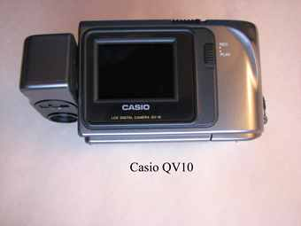
Cameras with articulating bodies and articulating screens are still being manufactured today. With these cameras pictures can be taken from any angle such as overhead, out a window, pointing the camera at the subject but looking in another

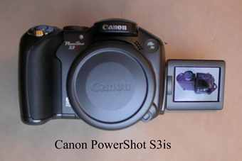
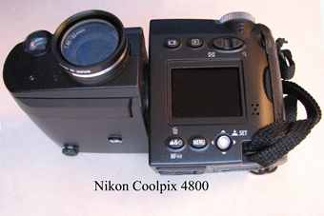

The main advantage to a digicam with an EVF is that it is TTL focusing there is no parallax error when looking through the viewfinder. What you see is what you get. An EVF or optical tunnel viewfinder is a necessity if the LCD panel fades out in the sun or the battery power is low. If the digicam has a zoom power over 5X the EVF is the only eyelevel viewfinder available. The tunnel optical viewfinder is not an option.

The disadvantages of an EVF consist of slower reaction to changing views, the resolution is lower than an optical viewfinder, because it has an LCD it uses battery power, and it freezes between shots with rapid sequential shooting.

The old optical tunnel viewfinder has several advantages the first is that it always works, it uses no power and, light goes directly through the camera without changing just like the optical TTL viewfinder in an SLR. The optical tunnel viewfinder is ideal for someone who likes to hold the camera to the eye to shoot a picture.

Because the optical tunnel viewfinder does not use the photographic lens about 85% of the image is not seen, parallax error, as a matter of fact the closer to the subject the greater the variance from the photographic lens. The optical tunnel viewfinder should not be used when shooting a picture of the sun because there is nothing to protect the eye.

The optical tunnel viewfinder and EVF are omitted from many cameras because the cameras can be smaller and it is less expensive to manufacture them.

The future

An LCD panel is made up of a white backlight that changes color as it passes through a crystalline material. It is the power hungry backlight that depletes the battery power. A new type of panel being investigated is the organic light emitting diode (OLED). The OLED is carbon based as opposed to the crystalline material used by the LCD. The carbon-based molecules can be sprayed on any material and do not require a backlight that makes OLEDs more power efficient, brighter, and with a wider angle of view. From a marketing standpoint an OLED is less complicated and less expensive to manufacture.

This article has been provided to APCUG by the author solely for publication by APCUG member groups. All other uses require the permission of the author (see e-mail address above).

